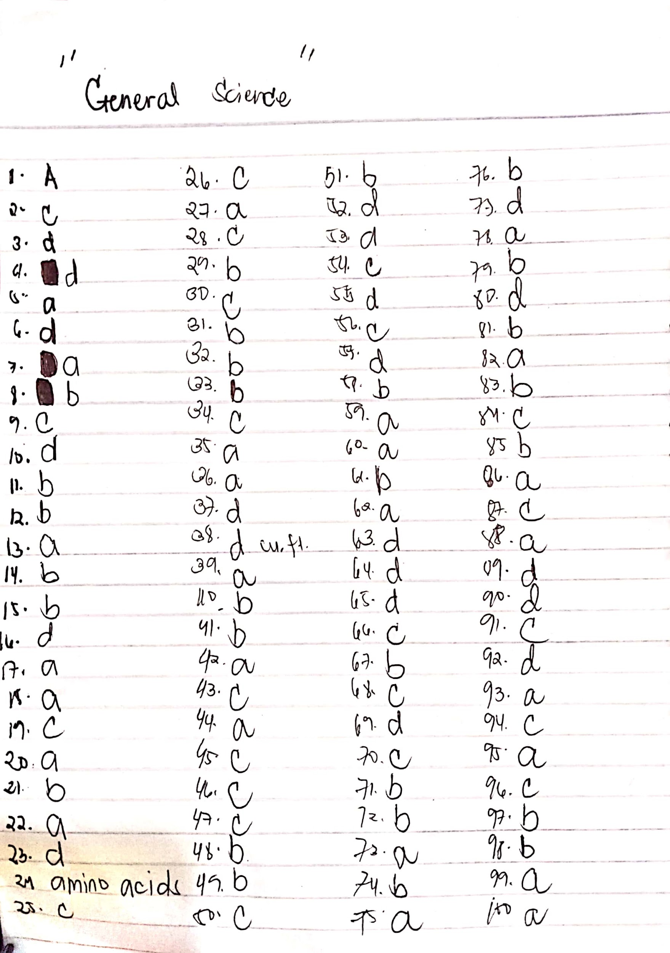GENERAL SCIENCE with answer key.. 1-100
POST – TEST
Good luck.
Multiple Choices:
1. These are living things that use sunlight, chlorophyll, water and carbon dioxide to produce food.
a. Autotrophs c. Heterotrophs
b. Consumers d. Food chain
2. It is describe as the lifeline of the body. IT is the body’s “pickup” and delivery system.”
a. Blood c. circulatory system
b. nervous system d. heart
3. It carries the oxygen-rich blood to the head, arms, and chest and down to the waist and the legs.
a. heart c. aorta
b. ventricles d. arteries
4. They are the transmitters of message from the different parts of the body to the brain and vice versa.
a. spinal cord c. brain
b. neurons or nerve cells d. arteries
5. Which part of the brain controls the following activities: breathing, blood pressure, heart rate, alertness?
a. brainstem c. cerebrum
b. hypothalamus d. spinal cord
6. Refers to a sequence of organism in a community that constitutes a feeding chain.
a. photosynthesis c. consumers
b. ecosystem d. food chain
7. Is a group of interacting plants, animals and human in a particular area?
a. ecological community c. living organism
b. environment d. food chain
8. Excessive presence of carbon dioxide in the air, trapping heat near the earth’s surface causing a rise in temperature in the environment.
a. El Nino c. Deforestation
b. “Greenhouse Effect” d. Weather disturbance
9. The Earth’s shield against sun’s harmful radiation.
a. Atmosphere c. Ozone layer
b. Air d. Forest
10. The use of product containing ______ is discouraged because they contribute to the depletion of_____.
a. Chlorofluorocarbon-solar radiation
b. Gas-ozone layer
c. Ozone layer air
d. Chlorofluorocarbon-ozone layer
11. What causes high and low tides?
a. Earth’s rotation on its axis
b. Moon’s gravitational pull
c. Sun’s solar energy
d. Earth’s gravitational pull
12. How is coral a tool formed?
a. Volcanic eruption
b. Corals growing around a volcanic island
c. Underwater bedrock formations
d. Earthquake
13. What is a long shore drift?
a. Movement of sand and shingles along the coast
b. Sand bars
c. Accumulation of sad at the river mouth
d. Island formed by volcanic eruptions
14. How does an occlusion form?
a. Cold air moving up from the ground
b. Cold front pushing warm air up of the ground
c. Unbalance electrical reaction in the air
d. Cold and warm air mixing in the atmosphere
15. What is a heat haze?
a. A reflection caused by pollutants in the air
b. A distorted image resulting from the bending o sun’s light rays by changes in air temperature
c. A movement o warm air over a vast expanse of land
d. Caused by extremely high temperature common in dessert areas
16. What sort of rock formation do the world’s greatest mountain ranges consist of?
a. Magma c. Fold eruptions
b. Chalk deposit d. Slip formation
17. What is the force that wears down mountains?
a. Earthquake c. Volcanic eruptions
b. Erosion d. Deforestation
18. How are volcanic island formed?
a. Collision of two oceanic plates
b. Cooling of lava by seawater
c. Volcanic eruptions
d. Accumulation of corals
19. When the Theory of plate Tectonics was generally accepted?
a. 1900’s c. 1960’s
b. 1930’s d. 1980’s
20. The weathering away of rocks by water, wind and ice.
a. Denudation c. Volcanic rock
b. Erosion d. Metamorphic rock
21. How do hormones work?
a. By releasing adrenaline
b. By controlling cell chemistry
c. By regulating water loss
d. By controlling blood pressure
22. Name the male and female sex hormones
a. Sperm cell & Ovum c. Chromosomes
b. Testosterone d. Red & white blood cells
23. The unit of measurement of energy in a given an mount of food
a. Pound c. Olfactory system
b. Kilo d. calorie
24. Nitrogen compounds known as the building blocks of proteins
25. The growth of roots towards water is an example of?
a. Chemotropism c. Hydrotropism
b. Geotropism d. Phototropism
26. DNA means
a. Data nurturing analysis c. Deoxyribonucleic acid
b. Deoxytribonucleic acid d. Deotrixyl nucleic acid
27. What are the three products of oxygen when it has been burned?
a. Water, carbon dioxide and heat
b. Energy, water and carbon dioxide
c. Energy, carbon and oxide
d. Energy, air and water
28. In flowering plants, fertilization happens in the?
a. Pollen tube c. Ovules
b. Stamen d. Pollen grain
29. The development of egg without fertilization
a. Mitosis c. Spermatogenesis
b. Parthenogenesis d. Mitochondria
30. Which of the following is a source of energy needed for photosynthesis?
a. Water c. Light
b. Soil d. Fertilizer
31. Chemistry is primarily concerned with the composition and changes of?
a. Nature c. Man
b. Matter d. Earth
32. A scientific theory is
a. A hypothesis not yet subjected to experimental test
b. An idea that correctly predict the result
c. An imagination
d. A guess
33. Which of the following units of measure is equivalent to cubic centimeter?
a. Milligram c. Millimeter
b. Milliliter d. Centiliter
34. Which of the following is NOT a compound?
a. acetic acid c. magnesium
b. alcohol d. Zinc Oxide
35. The easier the atom to receive electrons is measured by its?
a. Elecrtonegativity c. Number of shells
b. Atomic radius d. Valence electrons
36. The willingness o an atom to receive electron is measured by its?
a. Electronegativity c. Atomic size
b. Ionization potential d. Electron affinity
37. A molecule is said to be polar or dipole if?
a. Its positive and negative charges are at different places
b. It possesses polar bonds
c. Its’ polar bond have unsymmetrical charge distribution
d. All of the above
38. Which of the following is NOT a physical property of water?
a. freezing point at 0 degree C
b. boiling point at 100 degrees C
c. its’ heat of fusion at 80 cal/g.
d. its’ density at 4 degrees at 1 lb/cu. Ft
39. Which of the following statements is true?
a. Molecular weight does not influence boiling and melting point of a substance
b. Boiling and melting point tend to increase with molecular weight
c. Boiling and melting point tend to decrease with molecular weight
d. None o the above
40. A Mole is the amount of substance or a mass of a substance that contains?
a. 6.02 x 1023 particles c. 6.02 x 1023 particles
b. 60.2 x 1023 particles d. 60.2x 1023 particles
41. It is the measure of the amount of matter in an object
a. Weight c. Volume
b. Mass d. Quantity
42. It is the distance traveled by the body per unit time and tell how fast or slow the body moves
a. Velocity c. Acceleration
b. Speed d. None of the above
43. The rate of change of the distance traveled per unit time in a stated direction
a. Velocity c. Acceleration
b. Speed d. None of the above
44. This law states that the force acting upon an object is equal to the product o the mass and acceleration of the object
a. Newton’s 2nd law of motion
b. Newton’s 3rd law of motion
c. Newton’s 1st law of motion
d. None of the amount
45. When a force is applied to a body, several effects are possible. Which one of the following effect CAN”T occur?
a. the body rotates
b. the body changes direction
c. the body increase its mass
d. the body changes shape
46. It is the reluctance of the object to change either its’ state of rest or uniform motion in a straight line
a. Force c. Inertia
b. Friction d. Motion
47. This law states that energy cannot be created nor destroyed but only changes from one form to another
a. Energy law
b. Kinetic Theory of Matter
c. Law of Conservation Energy
d. None of the above
48. This law states that matter is made up of a large number of molecules which are in continuous motion
a. Boyles’s Law c. Law of Conservation Energy
b. Kinetic Theory d. None of the above
49. The lowest possible temperature that a substance can reach
a. Freezing point c. Steam point
b. Absolute Zero d. Threshold
50. It is the amount of heat required to raise the temperature of kg. of a substance by degree C
a. Calorie c. Specific heat capacity
b. Watt d. Joule
51. The relationship of give-and-take of living organism in the biosphere is a balance of nature called________.
a. universal relationship
b. symbiotic relationship
c. spontaneous relationship
d. abiogenetic relationship
52. Process of removing excess odor in water.
a. sedimentation c. distillation
b. chlorination d. aeration
53. Which of the following statement is CORRECT?
a. As altitude increases, atmospheric pressures corresponding
b. Throughout the available space, gas tends to contract
c. Equal chances are always given to all in life
d. Shadow is formed when a colored object is projected against the wall
54. The earth rotates on its axis from west to east. This causes the sun to _______?
a. appear with a fiery orange color
b. cause the appearance of solar eclipse
c. rise room the east and sets in the west
d. emit solar radiation
55. One of these planets has the greatest gravitational pull. Which one is it?
a. Mars b. Earth c. Mercury d. Jupiter
56. It is the law which explains why one can pull a piece without topping a glass in a quick motion.
a. energy in motion c. law of inertia
b. gravity d. force
57. Which of the following is NOT a source of energy?
a. water c. geothermal heat
b. nuclear d. inertia at rest
58. Which instrument will one use to convert mechanical energy to electrical energy?
a. rotor b. generator c. motor d. circuit
59. Sun’s energy is generated by?
a. nuclear fission
b. sun enacting with gravity
c. nuclear fusion reaction
d. reaction with magnetic field
60. Application of energy is called _______?
a. work c. kinetics
b. inertia d. simulation
61. The falling of any form of water from the air to the earth’s surface
a. Condensation c. Water vapor
b. Precipitation d. Rainwater
62. The part of the atmosphere that filters the ultraviolet rays of the sun
a. stratosphere c. Ozone layer
b. Troposphere d. Ionosphere
63. The point in the earth’s orbit nearest to the sun
a. Solstice c. Aphelion
b. Eclipse d. Perihelion
64. A property of minerals which gives off rays of light when exposed to ultraviolet light.
a. Luminescence c. Radiation
b. Phosphorescence d. Fluorescence
65. Which process involves chemical weathering?
a. Carbonation c. Hydration
b. Oxidation d. All of the above
66. How long does it take for the earth to complete one rotation
a. 365 days c. 24 hours
b. 30 days d. 12 hours
67. What is the principal function of gravity in the universe?
a. Provision for energy
b. Keeps the stars and other heavenly bodies in orbit
c. Causes movement in space
d. Part of universal design
68. What does the word “monsoon” mean?
a. Moon will soon come c. Seasons
b. Rains d. Wet weather
69. Its’ discovery enable geologist to date rocks accurately
a. layering c. Radioactivity
b. Evolutionary staging d. Carbon-dating
70. It occurs when the earth is between the sun and the moon, with the earth’s shadow cast over the moon.
a. Total eclipse c. Solar Eclipse
b. Lunar eclipse d. Partial Eclipse
71. Male and female reproductive part of a flower
a. Pollen grains and ovules c. Pollen grains and pistil
b. Stamen and pistil d. Stamen and ovules
72. In the human body, the cell that most nearly resembles a one-celled animals
a. Red Blood cell c. Nerve cell
b. White Blood cell d. Antibodies
73. The main energy source of a plant-eating animals
a. Glucose b. Starch c. Cellulose d. Glycogen
74. These are cellular secretions which help regulate the breakdown and buildup of various substance in the body
a. Enzymes c. Plasma
b. Amino Acids d. Hormones
75. It is the energy source of the cell which it uses for growing, reproducing and other activities
a. Adenosine Triphosphate c. Chloroplast
b. Amino Acids d. Sunlight
76. It is a segment of DNA molecule which controls the appearance of a given trait
a. Chromosomes c. Gametes
b. Genes d. Zygotes
77. Group of similar cells performing similar functions together
a. Organs b. System c. Nucleus d. Tissue
78. The diffusion of water through a semi permeable membrane
a. osmosis c. Transfusion
b. permeability d. Capillary
79. It shows the complex food relationship of organism in a given area and the cyclic flow of food through organisms
a. Food chain c. Food pyramid
b. Food web d. Biological cycle
80. Which of the following does NOT occur to both respiration and fermentation?
a. energy is released
b. sugar is broken down
c. carbon dioxide is produced
d. alcohol is formed
81. Energy removal is best illustrated in
a. boiling of liquid substances
b. changing water to ice
c. changing water to stem
d. none of the above
82. Refers to the maximum amount of solute expressed in grams that can be dissolved in 100 grams of water at a specific temperature
a. Solubility c. Molarity
b. Stability d. Molality
83. Compounds with the same molecular formula but with different structural formulas
a. Cellulose c. Polymers
b. Isomers d. Monomers
84. The most penetrating type of radiation given of by radioactive elements
a. Alpha particle c. Gamma particle
b. Beta particle d. None of the above
85. The basic unit for expressing the masses o individual atoms
a. Atomic number c. Nucleus
b. Atomic mass unit d. Atomic weight
86. A substance that speeds up a chemical reaction without itself undergoing a chemical change
a. catalyst c. Electrolytes
b. Enhancer d. Ionizer
87. The temperature at which the vapor pressure of the liquid is equal to the pressure of the surroundings atmosphere
a. Melting point c. Boiling Point
b. Critical point d. None of the above
88. the warming of the earth’s surface due to an increase in atmospheric carbon dioxide
a. “Greenhouse effect” c. Atmospheric pressure
b. Ozone d. El Nino phenomena
89. Describe the force of gravity on an object
a. mass c. capacity
b. weight d. pressure
90. When gaseous molecules are compressed, they tend to?
a. increase in volume c. repel each other
b. decrease in volume d.attract and liquefy
91. It is the union of two light nucleus to form a heavier nucleus, resulting in a mass defect and release of energy
a. Radiation c. Nuclear Fusion
b. Nuclear Fission d. Radioactivity
92. Which of the following statements is a characteristic of an electronic spectrum?
a. They all travel at the same speed in fire space
b. The exhibit diffraction and interference phenomena
c. They follow the laws of refraction and reflection
d. All of the above
93. The term “RADAR” is derived from the phrase?
a. “Radiation Detection and Ranging “
b. “Radiation Diffusion and Ranging”
c. “Radio Diffraction and Resolution”
d. “Radiation Diffraction and Resolution”
94. A material whose ability to conduct electricity lies between those of conductors and insulators
a. Integrated Circuits c. Semiconductors
b. Silicon Chips d. Insulators
95. “LASER” is derived from the phrase?
a. Light Amplification by Stimulated Emission of Radiation
b. Light Application by Simulated Emission of Radiation
c. Light Amplification by Simulated Ejection of Radiation
d. None of the above
96. What is the color of a transparent substance?
a. The color of the light it absorbs
b. The color of light it reflects
c. The color of light it transmit
d. The color of light it refracts
97. What is a rotating electromagnetic called?
a. Motor b. Rotor c. Phasor d. Sensor
98. What happens with the centripetal force when sped is doubled?
a. remains the same c. triples
b. force is increase 4x d. force is doubled
99. What is an electrochemical cell in which the reacting materials can be renewed by the use o reverse current
a. Storage cell c. Fuel cell
b. Primary cells d. Chemical cell
100. What will make an object move in a circular path?
a. Central force c. Frictional force
b. Gravitational d. Electromagnetic force
***** THE END *****

